|  |  |
| --- | --- |
| SDA project report  Final project | Abstract  The testing documentation of websites (https://www.demoblaze.com/ and https://reqres.in/) was displayed in the report and included defects, test cases, testing kinds, and so on. Mamunur Islam  *Tester* |

**Contents**

**Headings Pages**

1. **Document propose 2**
2. **Testing section 2**
3. **Testing checklists 3**
4. **Detailed test cases 4**
5. **Founded issues/bugs 5**
6. **Improvements 6**
7. **Test design techniques 7**
8. **Reflection**
9. **Document purpose**

In this document, the tester wants to test the specified websites <https://www.demoblaze.com/> and <https://reqres.in/> . To find out some key aspects which are:

* Defining testing area
* Functionality section testing
* Forming test cases

And so on.

1. **Testing section**

Using browser, [Demoblaze](https://www.demoblaze.com/), it is recommended to land to specified website. And it is shown that in main menu there are some section which is illustrated the below picture while in a drawing it is specified the interest of tester to test the components.

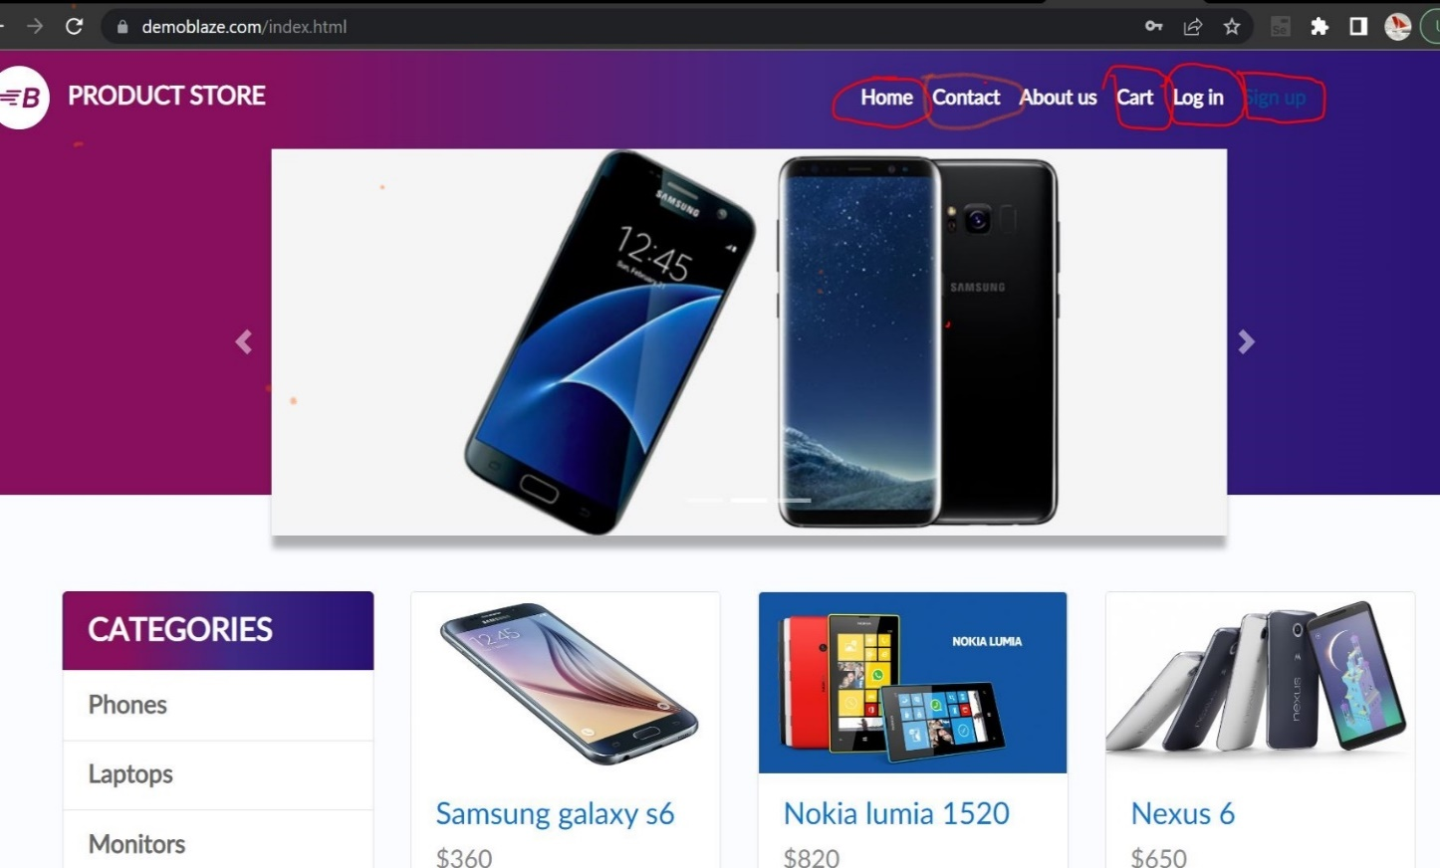Which are: Sign up, Log in, Contact, Cart and Home functionality

The API testing program Postman is used by the tester to send GET, POST, PUT, and DELETE requests to change the data while visiting the website https://reqres.in/. There is a needed paperwork for carrying out the operations on the mentioned website.

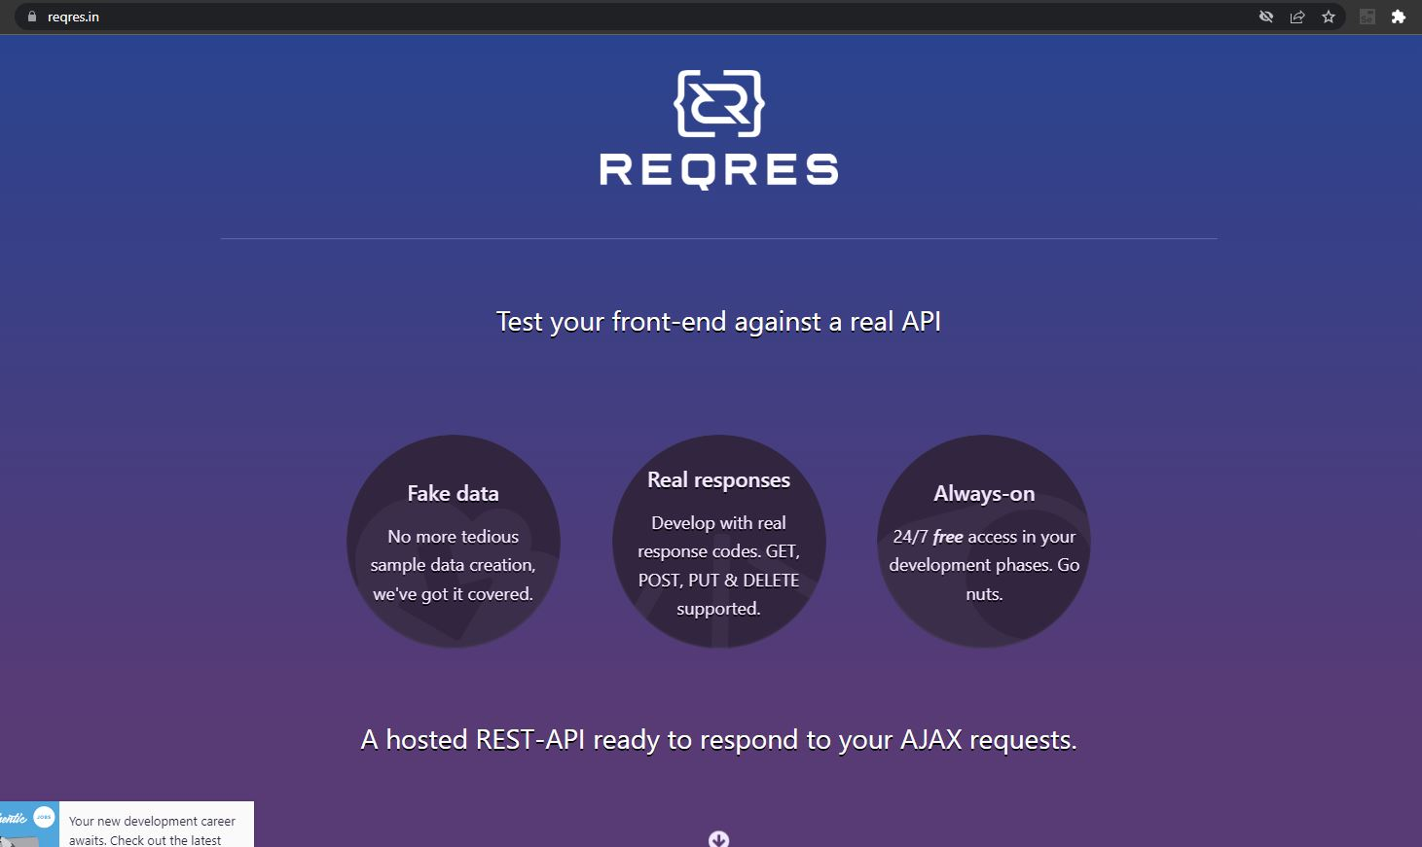

1. **Testing checklists**

The Demoblaze (<https://www.demoblaze.com/>) website is a commercial website. And the tester intends to do some feature testing alongside checking responsiveness of the website, which are specified below:

**Sign up:**

* Form correctness
* Registration

**Log in:**

* Adding new account
* Editing account

**Buying product and cart:**

* Using account trying to add in cart
* Delete from cart
* purchasing

**Log out:**

* Checking if log out options work correctly

**Contact:**

* Checking if message send correctly

On the other hand the reqres (https://reqres.in/) website is completely build to test APIs. In this website the tester used the requests like

GET- to find the data and successful response

POST- to post some data and check changes accordingly

PUT- to update the data and

DELETE- to delete the data

1. **Detailed test cases**

The detailed test case section will show how the test cases formed (a blend of high level and low level test cases) and below the screenshots are attached taken from related software like Jira and Testrail using Snipping tool.

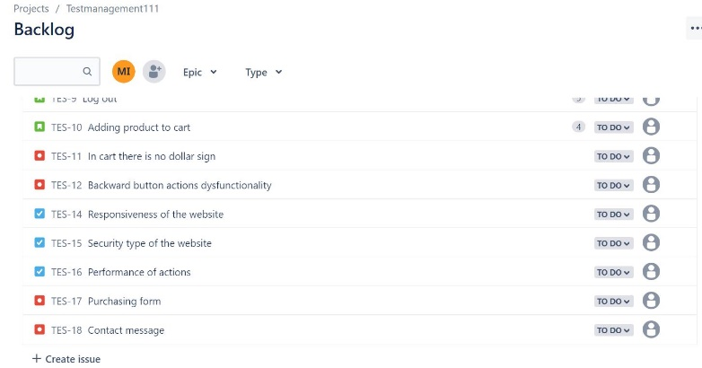**Demoblaze website’s cases and data:**

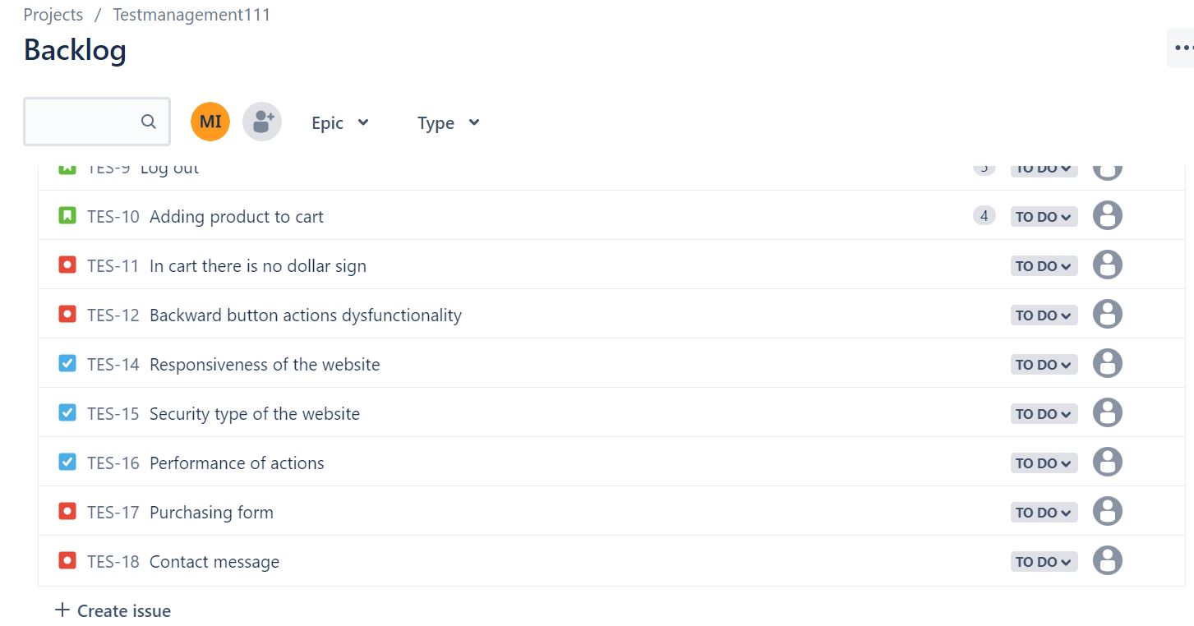

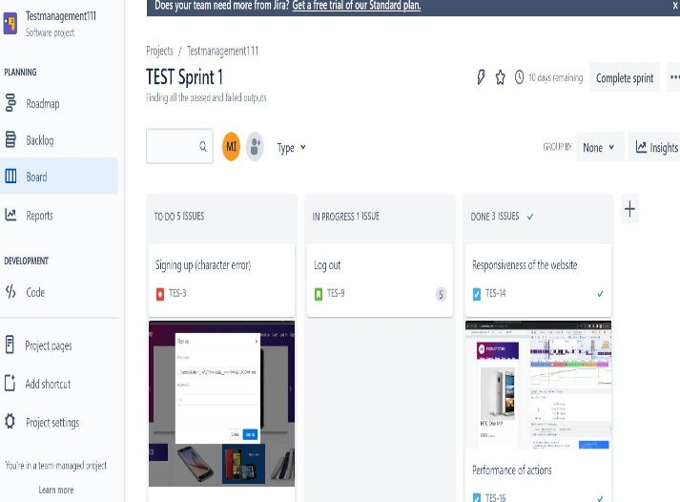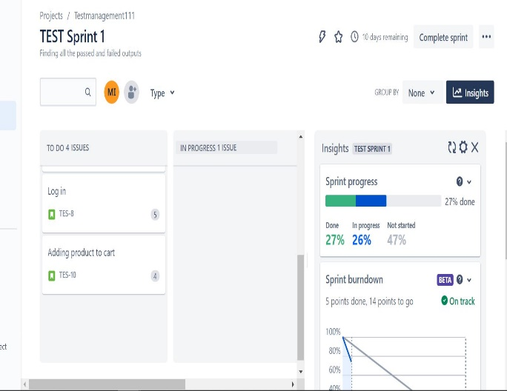

However, a failed operation and numerous passed requests and responses were discovered while testing APIs in [Reqres](https://reqres.in/). Pictures from the software TestRail are provided below.

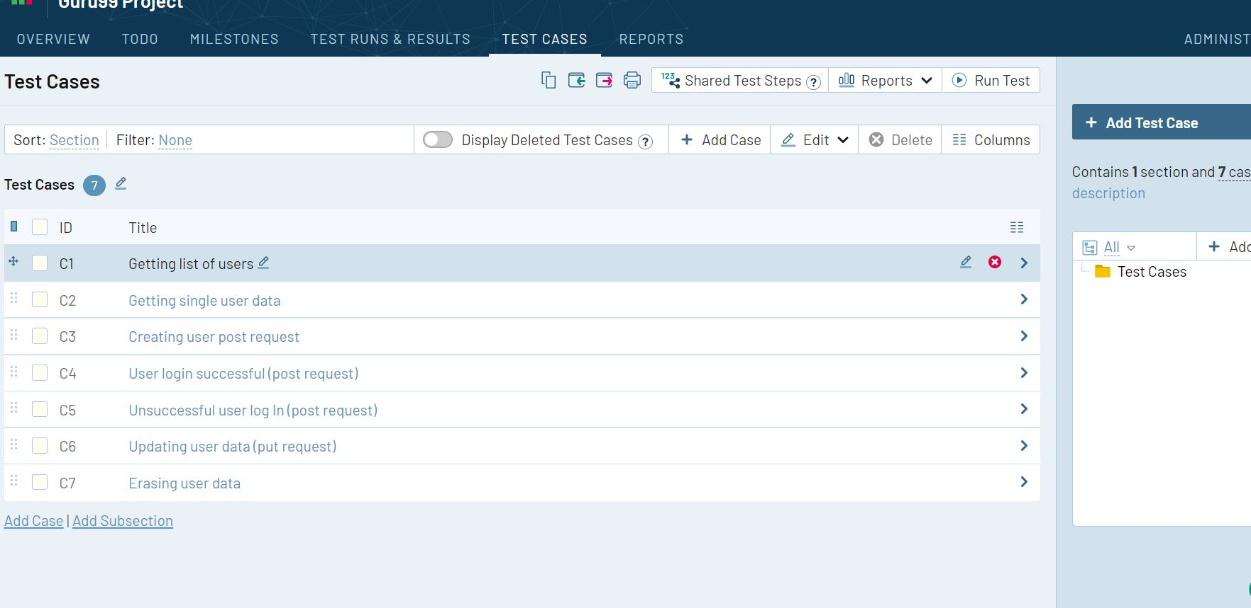

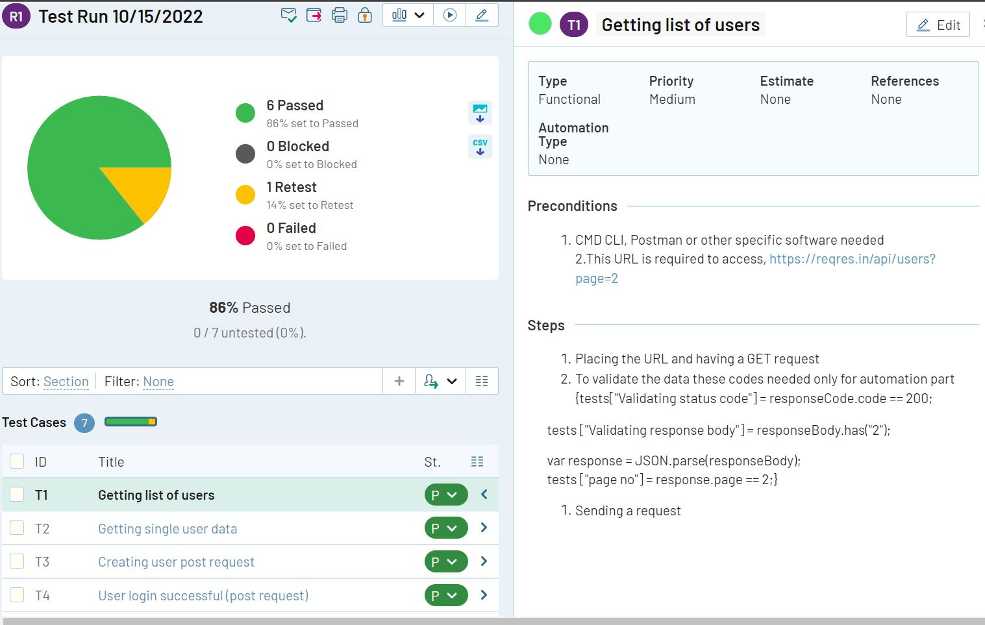

For more information [click](https://www.dropbox.com/sh/af7cga71xosmdfo/AAB4emvldD7FKe53skeVa_BQa?dl=0) here.

1. **Founded Issues/bugs:**

In [Demoblaze](https://www.demoblaze.com/), there are several bugs founded which are mostly functional bugs and most of them are crucial and immediately need to fix. However, there are no other types of bugs founded. Below one attachment added.

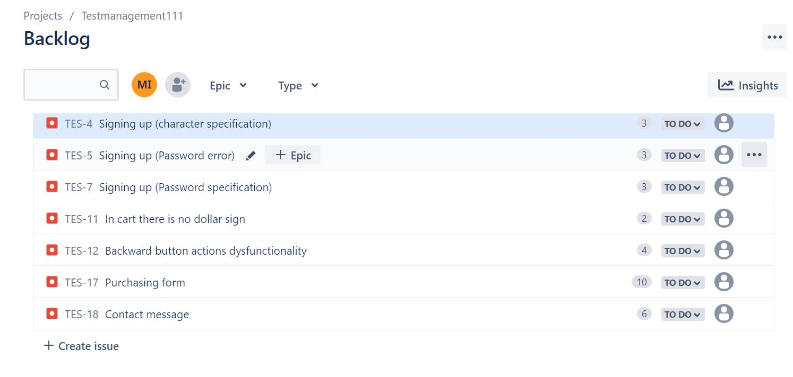

1. **Improvements:**

Despite the obvious problems, the color and design of the homepage were pleasing, even though the footer is static. If certain links were changed to point to different pages, that would be helpful. Additionally, the "about us" page merely performs a shutter down and does not transfer you to a new page.

1. **Test design techniques:**

The test design technique used during the period:

* Black box
* Exploratory testing

1. **Reflection:**